

**SAFEGUARDING MATTERS**

**May 2025**

**Ensuring cricket in Cambridgeshire is a**

**welcoming, safe, inclusive and enjoyable sport for young and old.**

**SEASON IN FULL SWING**

Forgive the cricketing pun in the title but with the weather considerably better than this time last year everyone should have got plenty of cricket in by now. It is about 6 weeks since my last newsletter and I want to keep a consistent flow of communications with you all, particularly through the season. Hopefully roughly every 6 weeks is about right for everyone. I will also send the occasional email with updates and reminders in between which I hope you will have seen a couple of weeks ago.

I always try to keep the newsletter succinct as I appreciate your volunteer time is precious. The content I include is always relevant to your roles at your clubs, indeed over the past two months I have found myself responding to queries from some of you the answers to which were already included in a recent newsletter. In order to continue to keep ‘Safeguarding’ in everyone’s thoughts this newsletter is again being sent to main club contacts as well as CSOs- Safeguarding is Everyone’s responsibility not just the CSO.

**Please take the time to read and digest and then share the relevant messages with your committees and members.**

This edition:

* Safe Hands Management System Version 4.0 release
* CSO webinar- Club self assessment and Low Level Concerns
* Low level concern reporting
* Recreational club safeguarding self assessment
* CSO visibility- a challenge for you all!!
* Regulated activity and DBS checks
* Survey prize draw results!!!
* Inclusion officer role

**SAFE HANDS MANAGEMENT SYSTEM V4.0**

Version 4.0 of the SHMS was released on 8th May and includes a number of updates bringing enhanced features to streamline club compliance management and improve the overall user experience for clubs.

Full details can be found here:

[SHMS V4.0 Coming Soon – May 2025 – Safe Hands](https://safehands.zendesk.com/hc/en-us/articles/26819267979293-SHMS-V4-0-Coming-Soon-May-2025)

SHMS is a valuable tool to ensure clubs manage their participants and understand their safeguarding risk and operational requirements, it is essential that club information is up to date. By keeping data accurate, clubs help ensure they meet the latest safeguarding and operational standards set by the ECB. This not only ensures compliance but also protects members and the wider cricket community.

The following link should be your first stop with any queries you have with SHMS

[**SHMS Help Centre**](https://safehands.zendesk.com/hc/en-us)

If you still cant find the answer you are looking for then please email my colleague neil.liversedge@cambscricket.org.uk

**CSO WEBINAR – cLUB sELF-ASSESSMENT & lOW lEVEL cONCERNS**

I will be running two webinars in June for CSOs. They will focus on the new Recreational Club Safeguarding Self-assessment form from the Cricket Regulator and Low Level Concerns. I have made them online and selected two different weekday evenings to hopefully maximise availability, they will take no longer than 90 minutes and that will include an opportunity for Q&As. The content will be the same for both so you only need to attend one. My colleague, Neil Liversedge, who is our Cricket Development Officer for coaches, officials & volunteers will also be supporting me and can help with queries regarding SHMS and DBS amongst other things.

The dates along with a link to book are below, please make every effort to attend.

Mon 2nd June 6.30 to 8pm <https://booking.ecb.co.uk/7MaqV4>

Thurs 12th June 6.30 to 8pm <https://booking.ecb.co.uk/WyzKOL>

**LOW LEVEL CONCERNS REPORTING**

I have seen a slight increase in reports of Low Level Concerns from our recreational clubs at the start of this season, that is actually a positive change as it tells me that there is a culture of openness and transparency from you all with a willingness to report.

As a reminder a Low Level Concern is a one about behaviour that doesn’t meet the threshold of causing harm but is against your club’s code of conduct or just behaviour that creates a nagging doubt or ‘unease’. Often it involves inadvertent or thoughtless actions that cease when addressed but can in some circumstances be a pre-cursor for more serious abuse. Examples are swearing in front of a junior player, direct social media contact with a junior, not following policy regarding use of photos, coach giving a lift home to a junior alone, the link below explains in more detail.

[Low-Level-Concerns-Guidance-Clubs.pdf](https://resources.ecb.co.uk/ecb/document/2024/11/18/e417ca1e-0a5b-4c93-9d56-3e09669fb08b/Low-Level-Concerns-Guidance-Clubs.pdf)

If you have something that you feel fits the criteria for a Low Level Concern then please contact me on email or phone so we can discuss.

**RECREATIONAL CLUB SAFEGUARDING SELF ASSESSMENT**

The Cricket Regulator has recently added a new resource to the ‘Safeguarding Kitbag’ to support you in making your club a safe and welcoming environment. The self assessment form is a simple checklist that you can use to identify any risk areas and then action plan to mitigate them. I would be really keen to hear from anyone that makes use of this, I would be happy to come and visit your club to go through it with you.

Give it a go and maybe use it to present to your committee to show what a great job you are doing in keeping all of your members safe!!

Follow this link to access it [Recreational-Club-Safeguarding-Self-Assessment-Report.pdf](https://resources.ecb.co.uk/ecb/document/2025/04/14/8757cd82-124e-4305-8253-6155e8726538/Recreational-Club-Safeguarding-Self-Assessment-Report.pdf)

**Regulated activity and dbs checks**

I just wanted to take the opportunity to remind you all of the roles at your clubs that require an ECB DBS check to be carried out. This link gives the definitive list [Who needs a DBS check? – Safe Hands](https://safehands.zendesk.com/hc/en-us/articles/6662671221405-Who-needs-a-DBS-check)

but the one role in particular that I wanted to highlight is that of captain. It has become evident that some clubs so far this season have been playing games without their captain having a DBS.

Please make sure your club is compliant in respect of this as it is part of good Safe Hands and is linked to your affiliation agreement.

**Club safeguarding officer visibility- a challenge for you all**

The pictorial below is taken from the ECB’s Health of Cricket 2025 report. The headline figure is that 1 in 5 recreational players do not know who their Club Safeguarding Officer is and subsequently there is a knock on effect that means they have less confidence in reporting a concern.

The challenge I have for each of you is to ask yourselves what that figure would be at your club??

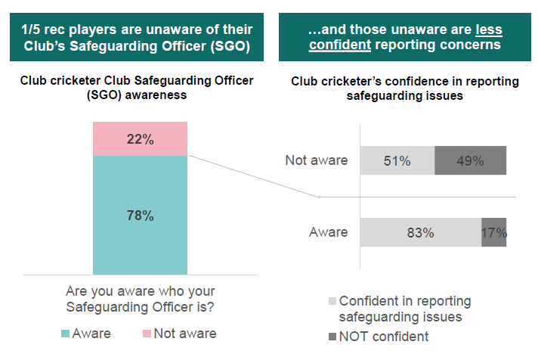

The safeguarding kitbag has resources to help with promoting visibility and I am always here to support and advise.

**SURVEY PRIZE DRAW RESULTS!!**

I have had 15 responses to the survey in last month’s newsletter, thank you to all who took the time to complete it. The answers received have been helpful for me to assess what help and support is required out there for you volunteers, the two online workshops set for June are an example of this.

As promised we have drawn two names at random from those who took the time and they will both receive a £25 Mr Cricket voucher. The lucky recipients are:

**Dan Thomas from Elmdon CC**

**Richard Coxhead from Isleham CC**

Congratulations to both I will be in touch soon.

Its not too late to complete the survey, your feedback is always gratefully received.

<https://forms.office.com/e/sE4zavrAuD>

**INCLUSION OFFICER ROLE**

My role as County Safeguarding Officer is for 15 hours a week which I tend to work across the whole week (and sometimes weekends), from this month onwards I have taken on an additional day a week as Inclusion officer for Cambridgeshire Cricket.

This role is about making cricket in Cambridgeshire as inclusive as possible, something which is closely linked to safeguarding, with the ultimate goal of making more people in our county whatever their background say ‘cricket is a game for me!’ whether that be as a player, official, administrator or any other volunteer role. The more people we can attract to our game because it feels inclusive then the better that is for its future.

Look out for separate comms from me on this and please share with your club committees, if you have any good examples at your clubs about how you make them more inclusive then please share them with me.

**THANKS FOR READING**

Thanks for reading and please make sure you share the information I have given you with the relevant people at your club. As always I want to remind you that I am always willing to come and visit you at your clubs to watch some junior training, a match or even attend a committee meeting to talk about safeguarding so please invite me along by emailing [safeguarding@cambscricket.org.uk](mailto:safeguarding@cambscricket.org.uk)

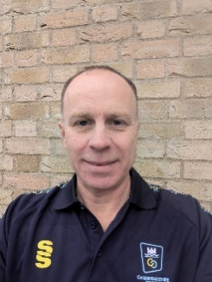

**Jamie Rice**

**Cambridgeshire Cricket County Safeguarding & Inclusion Officer**

[**safeguarding@cambscricket.org.uk**](mailto:safeguarding@cambscricket.org.uk)

**Safeguarding Concerns Number: 07537 830296**

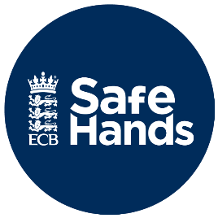

Link to the Cricket Regulator’s Safeguarding pages

[Cricket Regulator | Safeguarding](https://www.cricketregulator.co.uk/safeguarding)