
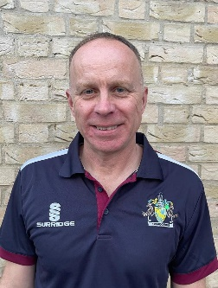
Jamie Rice
Cambridgeshire Cricket County Safeguarding Officer
safeguarding@cambscricket.org.uk
Safeguarding Concerns Number: 07537 830296
SAFEGUARDING MATTERS
Ensuring cricket in Cambridgeshire is a welcoming, safe, inclusive and enjoyable sport for young and old.

Hello!
At last the season is upon us and after a damp start we are starting to see some cricket which is great news. I am hoping you will have seen my introductory email sent out last month, I want to now follow that up with my first Safeguarding Bulletin which is something I want to try and do regularly to maintain my communications with you all. Ive tried to keep it short and to the point so please take the time to read.
I have now been in post for two months and been busy getting to grips with the role, completing various training modules, online introductions with various ECB Safeguarding representatives plus of course getting to know my colleagues at Cambridgeshire Cricket. I have deliberately mentioned my Cambs Cricket colleagues because Safeguarding is very much a team effort for us, whilst I lead for the County on all Safeguarding matters it is very much a team effort to make sure we are doing all we can to make cricket a welcoming, safe, inclusive and enjoyable sport for young and old. Clearly at the forefront of that is yourselves as the ‘frontline’ of safeguarding at our clubs and overseeing our leagues, one thing that has been clear to me in the short time I have been doing this role is the great work that so many of you are doing in your own time to help us achieve that goal. Thank you!!

New website and logo
Hopefully you will have seen the new Cambs cricket logo and also the updated website, I am currently in the process of reviewing the Safeguarding pages on the Cambs Cricket site to make them more helpful with important information and links to useful ECB resources. Watch this space!!
Safeguarding | Cambridgeshire Cricket Limited (cambscricket.org.uk)
Low Level Concerns reporting
The ECB have introduced a new Low Level Concerns (LLC) reporting database which is designed to record any concern, no matter how small or seemingly insignificant, that an individual may have acted in a manner which is not consistent with ECB Safe Hands guidance. This database is designed to pick up trends that may indicate an underlying issue for a particular individual, up until now this type of incident was just recorded locally on our own spreadsheet and not shared so we would not pick up on concerns or trends that happened across different counties.
At this time if you have an issue that you feel may be relevant for an entry on the LLC database then please contact myself at safeguarding@cambscricket.org.uk so we can discuss the best course of action
Any incident meeting the threshold for a referral to the ECB Safeguarding Team should as always be reported using an ECB referral form.
Scorers Safeguarding guidance
In response to a request made at a recent ACO committee meeting I have produced the attached guidance to assist scorers and other club officials with their responsibilities with regards to safeguarding whilst scoring.
Safeguarding While Scoring Document
Social Media reminder
I recently attended a Digital Webinar titled Social Media and the Digital World that gave lots of guidance regarding the risks of Social Media use to cricket clubs and personal users.
I thought it would be a good time to remind you all to make sure your club’s Social Media policy is up to date and fit for purpose, the ECB Safeguarding kitbag has a useful document on Social Media, Online Communication and Online Safety accessed here.
Social-Media-Online-Communication-and-Online-Safety.pdf (ecb.co.uk)

A plea from me
I want to repeat the plea in my previous bulletin because I had a limited response from you all. I am here to support you as volunteers so I want to meet as many of you as possible at your clubs to witness first hand the good work that you are all doing. Over the past couple of months I have attended junior training at Therfield (Royston CC) on a Sunday morning and also a junior match at Cottenham, at both of these I have been able to have a good chat with club officials to hear about their work and plans for their club in the future, there is some great work going on out there (not just in terms of safeguarding) and as a club cricketer myself I love to come and watch and talk cricket.

Please contact me with details of your junior training sessions or any festival/competition that you are running so I can come along.

I hope you have enjoyed reading this bulletin and found it useful, please let me know if you have any feedback or suggestions for future content. Thanks for reading and have a good season!
Jamie

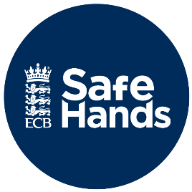
Link to the ECB Safeguarding pages
England and Wales Cricket Board (ECB) - The Official Website of the ECB

