
SAFEGUARDING & INCLUSION MATTERS
January 2026
Ensuring cricket in Cambridgeshire is a
welcoming, safe, inclusive and enjoyable sport for all.

HAPPY NEW YEAR!!
Happy New Year to you all, I hope you had a good festive break and managed to spend time with loved ones. The cricket in Australia didn’t give us much to cheer about and the current weather is pretty miserable so the only thing to do is start dreaming of the summer months that will soon be upon us. Whilst the season is still some way off it is important as clubs that you start thinking about what you need to do to be ready for the season ahead, so that will be the focus of this first newsletter of the year.

The observant among you will have noticed that the name of this newsletter has changed with the addition of the word ‘Inclusion’, that is to reflect the expansion of my role as County Safeguarding Officer and Inclusion lead. The two roles are very much interlinked with the overall goal of making cricket in Cambridgeshire a welcoming, safe, inclusive and enjoyable sport for all.

Please take the time to read, digest and then share the relevant messages
with your committees and members.

This edition:
- Useful resources for the season ahead
- Safe Hands Workshops 2026
- Spring 2026 Webinars for CSOs
- Updates to the Safety in Cricket Regulations & Guidelines PLEASE SHARE
- First Aid training
- CSO Whats App group
- Changes to the DBS process
- Inclusion in recreational cricket
- Thank you

useful resources for the season ahead
I have previously shared the Recreational Club Safeguarding Assessment and I use it when visiting clubs during the season. It is a useful tool for you to use when assessing your club’s status with regards safeguarding. It is a relatively simple checklist and enables you to action plan in order to embed safeguarding at your club. By using this now it will help you plan what actions you need to complete through the off season to be ready next Summer.
Recreational-Club-Safeguarding-Self-Assessment-Report.pdf

The Safeguarding Training Matrix is a useful reference document that clarifies what roles at your club need what Safeguarding training and also who needs an ECB DBS check.
Safeguarding-Training-Matrix.pdf

These two documents are essential reading for ensuring your club is ready in safeguarding terms for the season ahead.

SAFE HANDS WORKSHOPS 2026
We have two dates set for Safe Hands workshops this year, the links can be found below:
- March 19th 2026 6.30 to 9.30pm at Sawston, Mill Lane Pavilion, CB22 3HY (not the cricket club) https://booking.ecb.co.uk/Zyg9wO
- April 28th 2026 6.30 to 9.30pm at Over Community Centre, CB24 5NW
https://booking.ecb.co.uk/bABgAM
These are also on our website at Safeguarding training | Cambridgeshire Cricket Limited

***************These are the only two courses we will be running this year***************

As a reminder to be a fully compliant Club Safeguarding Officer you need to
- Attend an in person Safe Hands workshop every 3 years
- Complete the new online SGL2 training every 3 years accessed through this link https://booking.ecb.co.uk/89PLAG (or have completed the old SSR online training within the past 3 years)
- Have a current ECB DBS check.

SPRING 2026 WEBINARS FOR CSOs
I will be running two one hour webinars this Spring for Club Safeguarding Officers, they will be aimed at sharing updates and key messages for the season ahead. The links below will take you to the online meeting, content will be the same for both so only need to attend one. Ive chosen two different weekday evenings to hopefully maximise attendance. I will also email these out to CSOs as invites in due course.

Weds 11th March 7pm CSO Webinar 11th March
Tues 17th March 7pm CSO webinar 17th March

There will be an opportunity for Q&As but if you have any thoughts on what you would like covered in the webinar then please let me know.

UPDATES TO THE SAFETY IN CRICKET REGULATIONS & GUIDELINES
***Neck protectors, ball throwers & bowling machines***

The ECB circulated their updated Safety Regulations and Guidelines on 17th December and the below message from the ECB’s Safety in Cricket Officer highlights the main updates.
Please share with your club chair, coaches and junior sections.

The ECB was deeply saddened to learn about the death of a young cricketer in Australia in October 2025, who it is understood was struck in the neck from a ball delivered by a ball thrower (sometimes known as a ‘dog stick’). In light of this tragic event the ECB has reviewed its relevant safety regulations and policies, and is making the following updates:

- All cricketers are strongly advised to wear neck protectors at all times that they are required or recommended to wear helmets.
- It is recommended that ball throwers and bowling machines are only operated by adults who are suitably experienced, competent, and familiar with their safe operation. Bowling machines and ball throwers should not be operated by U18s.
- New Safety Guidelines for Training Environments have been created. These cover:
  - Safe set up and operation of net facilities
  - Operation of bowling machines
  - Use of ball throwers

The full updated Recreational Cricket Safety Regulations and new Safety Guidelines for Training Environments (found within the wider Recreational Cricket Safety Guidelines) can be viewed using the links below:
Recreational-Cricket-Safety-Guidelines-Dec-2025-Update.pdf
Recreational Cricket Safety Regulations_15.12.25

FIRST AID TRAINING
The England and Wales Cricket Board recommend that there should be a qualified 1st Aider in attendance at every formal training or coaching session you run and ideally at every game played.

As a Club Safeguarding Officer it is worthwhile checking what trained 1st Aiders you have at your club, if you feel your club would benefit from having someone trained then we are running two courses in the next couple of months.

Saturday 28th February at Chatteris Cricket Club running from 9.30 to 13.00.
The link to book is here - https://booking.ecb.co.uk/QO3zLo
Thursday 26th March at Mill Lane Recreation Pavilion, Mill Lane, Sawston running from 18.15 to 21.45.
The link to book is here - https://booking.ecb.co.uk/5010ba

The cost to join the course is £40 and is very competitive compared to other sports governing bodies and local course providers. The amount is purely to cover the cost of the tutor and venue.

CSO WHATS APP GROUP
We now have 18 members in our Club Safeguarding Officers Whats App group, I’m keen to increase that number to enhance the network of support.

Myself and colleague Neil Liversedge are also in the group to help with any questions. You will still have the Safeguarding email address and the Safeguarding mobile to call for specific queries but I see this group as one for any general points, good ideas, questions etc that would benefit you all from sharing and it will also help you feel you aren’t alone out there as a CSO.

Obviously this is optional for each of you but if you would like to be included in this group please email me at safeguarding@cambscricket.org.uk with your name, club and mobile number and I will add you.

CHANGES TO THE DBS PROCESS
I sent an email to all CSOs on 10th December outlining some changes to the DBS process but sharing here also as it may have been missed by some.

Firstly Atlantic Data have updated their Terms & Conditions which means users will have to read and accept them the next time they log on to the ECB DBS disclosures system.

Second point is any new ID verifiers will need to have attended a Safe Hands workshop as part of the legal requirement for them to be a verifier, this is so they understand the importance of the DBS and where it fits within the framework of Safeguarding. Anyone who is currently a verifier will be allowed to continue at this time without the need for this but please note there is a new restriction of not verifying ID of a ‘personal friend’. I interpret this as someone who you would spend social time with away from your club environment and not just another member whom you consider a friend through your club. As always I am here to help with this, I don’t want this to be a barrier for volunteers getting DBS checked promptly, I am happy to facilitate checks if in doubt.

Also of note is a new digital ID verification system is being introduced as an alternative to an in-person check later this year. More details to follow when known.

INCLUSION WORKSHOPS FOR RECREATIONAL CRICKET CLUBS
As I said at the top of this newsletter I am now leading on Inclusion for Cambridgeshire Cricket with the overall aim of making cricket as inclusive as possible in line with the ECB’s Cricket’s Core Values (see right).
As part of this I have started to deliver Inclusion workshops to clubs, these are focussed on getting committees, captains and other influential figures at your clubs thinking about how you can be more inclusive with the overall headline of
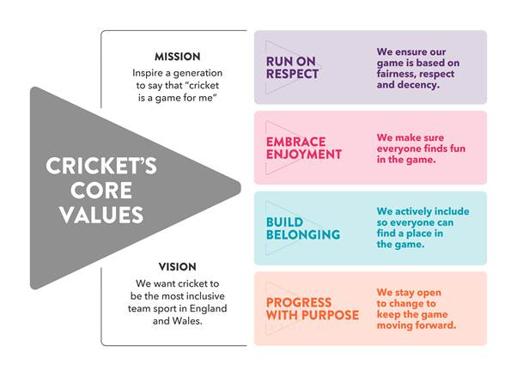

Inclusion = People = Sustainable club

The more people you can attract to your club in any capacity (player, volunteer, supporter) and whatever their background because it feels inclusive then the better that is for your club’s survival. If you think your club would benefit from a 2 hour workshop exploring how this could work for you then please contact me.

THANKS for reading and sharing
I appreciate that a lot of information has been shared here, thank you for taking the time to read, please share with relevant people at your club.
Please get one of the March webinars in your diary.
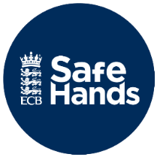

Link to the Cricket Regulator’s
Safeguarding pages
Cricket Regulator | Safeguarding

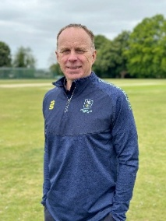
Jamie Rice
Cambridgeshire Cricket
County Safeguarding & Inclusion Officer
safeguarding@cambscricket.org.uk
Safeguarding Concerns Number: 07537 830296

