
SAFEGUARDING & INCLUSION MATTERS
June 2026
Ensuring cricket in Cambridgeshire is a
welcoming, safe, inclusive and enjoyable sport for all.

WARM AND DRY START

Well its been a hot and dry start to the season, great for players but a headache for grounds keepers. I am hoping there has been plenty of cricket played at your clubs for both young and old. As it has been a couple of months since my last newsletter I thought now would be a good time to communicate with you all again.

Of particular note in this edition is the new Crime and Policing Act 2026 which includes a mandatory duty to report child sexual abuse and a chance to win a Mr Cricket voucher for sharing examples of good practice in listening to members.

I appreciate this is a busy time of year for club volunteers but as always please take the time to read, digest and
share the relevant messages with your committees and members.

This edition:
- Crime and Policing Act 2026 ***IMPORTANT NEW LEGISLATION***
- Hot weather advice
- CSO roles and responsibilities ***REMINDER***
- New online DBS ID check
- Listening ideas competition ***WIN A £50 MR CRICKET VOUCHER***
- Mental Health First Aiders
- Low Level Concerns reminder
- Kit recycling display bins
- Thank you

CRIME AND POLICING ACT 2026
The Crime and Policing Act 2026 directly affects every sports organisation working with children and young people, from Premier League academies to grassroots clubs. Critically, the government specifically cited sports volunteers when designing the Act, recognising that millions of people give their time to support junior sport. The Act's design reflects this, but it still creates real new obligations that clubs, governing bodies, and coaches must understand and act on now.
The good news is that because of the Safeguarding procedures already in place in cricket we are in a good position and compliant in most areas.
-DBS & Safer Recruitment
Existing approach already exceeds the new requirements, coaches and assistants (and anyone supervising children) must have enhanced DBS.
-All Stars Activators and parent helpers
The current guidance stating that parents supporting more than 3 sessions should have an ECB DBS covers this. Additionally all clubs are encouraged to practice ‘Safer Recruitment’ to ensure robust checks and vetting are applied beyond DBS checks. All clubs should already be compliant with this and it is covered during safe Hands workshops.
-Mandatory Reporting
***This is a new obligation and should be shared with your fellow volunteers***
The Act introduced a mandatory duty to report child sexual abuse for those in regulated activity, including sports roles.
This is already reflected within the updated SGL3 Safe Hands workshop, which explains the expectations around mandatory reporting and reinforces that concerns involving statutory agencies must be reported to the County Safeguarding Officer (CSO).
For example, if a child discloses sexual abuse to a coach, the coach should report this to their Club Safeguarding Officer (CSO). The CSO must then escalate and work with the County Safeguarding Officer to ensure that mandatory reporting processes are followed.
However, the responsibility does not end there. The individual coach must follow up with their CSO to be confident that the concern has been properly escalated to statutory agencies.
Failure to do so may result in a referral to the Disclosure and Barring Service (DBS), which could lead to the individual being barred from working in child-facing roles.
The legislation reinforces that individuals cannot assume someone else has reported, they must be assured the appropriate referral has been made by their CSO.

The Cricket Regulator will be emailing all Club Safeguarding Officers directly in the near future regarding this but I wanted to give you all a ‘heads up’ in advance. Any questions then please don’t hesitate to ask.

HOT WEATHER ADVICE
It looks like the extreme temperatures of the past few weeks have subsided for now but I thought I would share this ECB document assuming that we will see temperatures rise again soon
Sun-Protection.pdf
A timely reminder even if much of it is common sense.

CLUB SAFEGUARDING OFFICER ROLE & RESPONSIBILITIES
I have been made aware recently of coaches at some clubs with expired DBSs which means they are not compliant and should not be coaching. This is usually because they have not properly followed the instructions for the DBS Update Service (see my article in my previous newsletter covering this).
I just wanted to remind all of the roles and responsibilities of a Club Safeguarding Officer, the Core Responsibilities section of this document
Appointing-and-Training-a-Club-Safeguarding-Officer.pdf
sets them out clearly but in particular I draw your attention to
- Ensure vetting applications are completed and everyone is aware of the roles requiring a DBS

I cannot check this for every club volunteer in regulated activity, I need you to be proactive in doing this at your club every year. Current and valid DBS checks are the first step in ensuring you have a safe club, if you need help in checking the volunteers in regulated activity at your club are compliant then please just ask me. I am here to help you with this.

ONLINE DBS ID CHECK NOW AVAILABLE
The more observant of you will have noticed that there is now an option for DBS applicants to have their ID verified online instead of an in person document check. There is a cost of £4.92 for this service (charged by Atlantic data not the ECB) however it may be more convenient for some to make use of this. In person ID verification is still available to all of course.

NB: The DBS system is a little confusing as when you as a CSO initiate a check you get a drop down with just the online ID check and no in person option. Don’t worry as the choice of online or in person is made by the applicant when they complete their details.

LISTENING IDEAS- WIN A £50 MR CRICKET VOUCHER FOR YOUR CLUB
What is your club doing to listen to its members? How do you know your junior members are enjoying their cricket? How do you know your junior members know how to report a concern?

Listening is a fundamental part of safeguarding, if your members feel they are being listened to then they are more likely to report a concern when one arises.

I want to hear what you are doing at your club to promote a listening culture, please share what you are doing with me so I can share across our network. As an incentive I am offering the opportunity to win a Mr Cricket voucher for the best examples.

MENTAL HEALTH FIRST AIDERS
All staff at Cambridgeshire Cricket attended a Mental Health First Aid training course back in the Autumn which gave us all a Level 2 qualification in First Aid for Mental Health. I am sharing this here to promote this across the county. If you have concerns regarding the mental health of someone at your club and feel they may benefit from some support please reach out to one of us in confidence to see if we can help.
Visit our website to see staff details
Meet the Staff | Cambridgeshire Cricket Limited
Low level concerns reporting
I make no apologies for including this in the newsletter again. It is vital that you are talking to me and sharing any concerns that arise at your clubs, however trivial they may seem to you. This is about transparency and openness in the recreational game.

We are encouraging low-level reporting across our game to ensure poor practice and unacceptable behaviour is recorded and addressed at an early stage. Low level does not mean it is insignificant just that it doesn’t meet the threshold for a referral to the Cricket Regulator.

The document in the link below explains on a page what a Low Level Concern is
Low-Level-Concerns-Guidance-Clubs.pdf

Here are some examples of LLCs we had reported in to us over the past year to give you an idea:
- Junior player making open age debut entered changing room whilst adults changing
- Umpire upset junior player through over officious language
- Aggressive behaviour by adult player towards a junior umpiring
- Unsafe outdoor net practice- no DBS adult present, poor organisation/discipline causing risk to public
- Coach left junior player alone at end of game before parents arrived to collect

Please email me with any incidents that you feel fit the definition of a LLC. If something doesn’t feel right to you then it probably isn’t so please talk to me.
Primarily this is about learning and preventing escalation not blame and sanctions.

kit recycling display bins
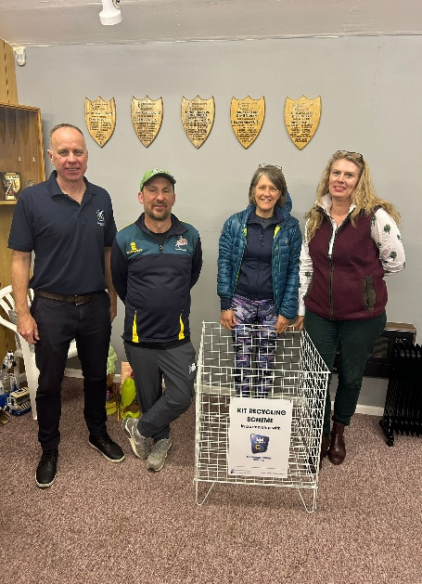
As part of our commitment to the ECB’s Vision to make ‘Cricket the most inclusive team sport in England & Wales’ and in particular reduce the barrier of cost to participants we are keen to encourage clubs to recycle second hand kit to make the game as accessible as possible to as many players as possible. To support clubs in doing this Cambridgeshire Cricket have secured funding for some kit recycling ‘display bins’ to enable you to store and display second hand equipment that can be used by players in need of kit.
We still have some bins available to any clubs who would like one, please contact me if you are interested.
Picture shows Chippenham receiving their display bin.

THANKS for reading and sharing
As always thanks for reading and sharing the key messages with relevant people at your club.
As a team we are here to help and support you and your clubs, please talk to us.

Don’t forget I’m always keen to come and visit you to watch a junior session or match and talk about your club.


Link to the Cricket Regulator’s
Safeguarding pages
Cricket Regulator | Safeguarding

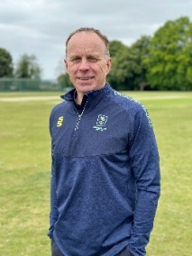
Jamie Rice
Cambridgeshire Cricket
County Safeguarding & Inclusion Officer
safeguarding@cambscricket.org.uk
Safeguarding Concerns Number: 07537 830296

