
SAFEGUARDING & INCLUSION MATTERS
Sept 2026
Ensuring cricket in Cambridgeshire is a
welcoming, safe, inclusive and enjoyable sport for all.

30 WEEKS UNTIL APRIL!!

This time of year is always tinged with sadness, the nights drawing in, temperatures dropping and no more cricket to enjoy whether as a player, official, volunteer or spectator. Never fear, its only 30 weeks until the beginning of April!!

With that in mind the work behind the scenes doesn’t stop for many recreational club volunteers. Many of you out there reading this will already be looking ahead to next season whether that is end of season renovations on your square, planning some out of season social events, thinking about fundraising for next year or recruiting new volunteers.

The work certainly doesn’t stop for us at Cambridgeshire Cricket either, we are still here throughout the winter planning and preparing for next year, I am here to support clubs with anything they need in terms of Safeguarding and Inclusion to ensure our sport is welcoming, safe, inclusive and enjoyable for all.

I appreciate that many of you will be looking forward to a break at this time of the season but hopefully you can find time to read and
share any relevant messages with your committees and members.

This edition:
- Inclusion, Discipline and Discrimination Regulations ***IMPORTANT***
- Living Better resources
- NSPCC Sport
- Recreational Clubs Safeguarding Self-Assessment

inclusion, discipline and discrimination regulations
********PLEASE SHARE THIS MESSAGE WITH YOUR COMMITTEE AND CAPTAINS*********
Unfortunately I am starting this edition with a subject that is having a negative impact on our game. Towards the back end of the season I have been made aware of several occurences of poor behaviour by players during games. I am specifically talking about homophobic, sexist, racist, misogynistic and disablist language being used by players on the field of play alongside generally negative attitudes towards some of these minority groups.

Banter and chat on the cricket field is a part of our game and is rightly used to motivate and encourage team mates and at times can be used to try and gain an advantage over opposition players, however it should NEVER be used to target individuals based on their gender, sexuality, ethnicity or any other characteristic.

Clubs and players should be aware that such behaviour is a breach of anti-discrimination regulations and can be dealt with through the discipline process leading to bans, fines and other sanctions. Captains and other leaders at clubs have a responsibility to show leadership in this area by challenging inappropriate behaviour by anyone involved in the game.

The Cricket Regulator pay close attention to reports of discriminatory behaviour and how they are handled as it has a direct impact on the ECB’s Vision of making Cricket the most inclusive team sport in England & Wales.

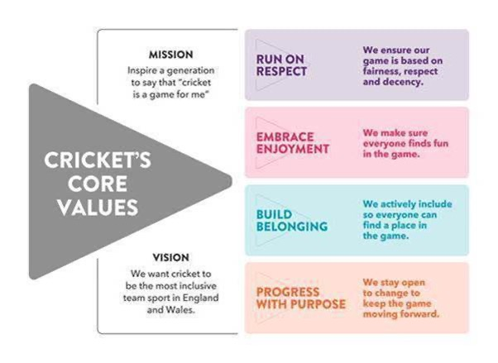

As Inclusion lead for Cambs Cricket I have been working with our Leagues to ensure we are taking a consistent approach in challenging this behaviour. I want to hear about occasions when discriminatory language and attitudes have been displayed so alongside the Leagues we can challenge and deal with it at an appropriate level. I am a strong believer in education over sanction in this area when appropriate.

If you would like to discuss how your club can become more Inclusive I would love to come and talk to you. I visited 12 clubs over the 25/26 off season and would be keen to do the same again this year. I am always available throughout the off season just email or phone so we can arrange a date.

LIVING BETTER
Living Better, formerly Living Sport, is a local charity in Cambridgeshire and Peterborough that works to improve community health and wellbeing through physical activity. They offer a number of resources for Safeguarding Officers including training webinars on various subjects throughout the year.

Active Bystander Workshop
We're pleased to share that planning is underway for the NWG Active Bystander Workshop, which will be hosted by Cambridge 99s Rowing Club on 1 October 2026, from 6:00pm to 8:00pm.
Fully funded by Sport England, this interactive workshop is open to anyone involved in sport and offers practical guidance on how to respond when witnessing bullying, harassment, discrimination, or other inappropriate behaviour.
To join the session, sign up here: Learn How To Become an Active Bystander

Sported
Living Better is pleased to be working in partnership with Sported, a national charity dedicated to helping grassroots sports clubs and community groups thrive.
Sported provides access to a network of professional volunteers who support organisations delivering sport and physical activity for young people aged 11–25. Their expertise covers a range of areas, including:
- Business planning
- Marketing and communications
- Fundraising
- Demonstrating impact
- Finance
- People management
- Club development

In addition to practical support, Sported can occasionally provide access to funding opportunities and connect clubs with other funding organisations.
As a member of the Sported network, you will also receive a monthly newsletter and free access to the Sported Hub, which contains a wealth of resources and guidance for community sports organisations.
Explore the Sported Hub: https://hub.sported.org.uk/

Spond
To help you keep up to date with local events, training opportunities, resources, and support available through the national Sport Welfare Officer Network, don't forget to join the Living Better Spond platform. I am in this Spond group and often get links to useful webinars shared.

As well as staying informed, Spond can also help clubs:
- Improve safeguarding practices
- Communicate safely with parents and members
- Simplify club administration
- Create a more organised and connected club community
Join for free here: Spond

NSPCC SPORT
The NSPCC's Child Protection in Sport Unit (CPSU) is now NSPCC Sport. While the name has changed, their mission remains the same: keeping children safe, supported, and able to thrive in sport. For over 25 years, they have helped organisations put children's welfare at the heart of everything they do.
Explore the new website: https://sport.nspcc.org.uk/
New features include:
• NSPCC Sport Podcast – practical safeguarding insights and conversations with experts from across the sport sector. https://sport.nspcc.org.uk/sport-safeguarding-courses-and-events/podcasts/
• NSPCC Sport Webinar Hub – watch recorded webinars covering the latest safeguarding topics and good practice. https://sport.nspcc.org.uk/sport-safeguarding-courses-and-events/webinars/

Well worth a look if you're involved in supporting children and young people in sport.

RECREATIONAL CLUB SAFEGUARDING SELF-ASSESSMENT
Sharing this link with you all as a useful tool to use out of the season for gauging where you are at as a club in terms of safeguarding. I’m happy to come and visit your club to go through this with any of you at any time of the year, please just ask.
Recreational-Club-Safeguarding-Self-Assessment-Report.pdf

THANKS for reading and sharing
That’s it for this edition, short and sweet.
On behalf of Cambridgeshire Cricket thanks for all of your efforts at your clubs this season to make the game safe and enjoyable for all.
If you need anything through the off season I’m still here and available to help.

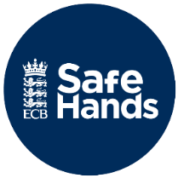

Link to the Cricket Regulator’s
Safeguarding pages
Cricket Regulator | Safeguarding

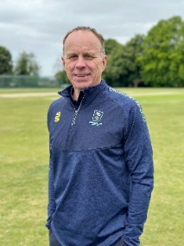
Jamie Rice
Cambridgeshire Cricket
County Safeguarding & Inclusion Officer
safeguarding@cambscricket.org.uk
Safeguarding Concerns Number: 07537 830296

